APPROVED
Vice-rector for Academic Affairs
VSU named after P.M. Masherov
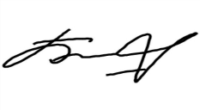Bobryk M. Yu.
«14» May 2024

SCHEDULE
Winter examination session of the 2023–2024 academic year for Master’s course students studying in English, daytime form of education of the specialty 7-06-0114-02
“Educational Management_1”
Enrolment September 2023

Examination period: 28.05.2024–10.06.2024

Discipline, teacher | Examination |  | Credit
 | Date, time | Classroom | Date, time | Classroom
Managing the educational process in the digital environment  Stepanov V.A. |  |  | 28.05.2024  9.35 | 212  33 Moskovsky Ave
Information and communication technologies in scientific, pedagogical and innovative activities  Sapelko T.I. |  |  | 29.05.2024  13.05 | 326  33 Moskovsky Ave
Research seminar  Rakova N.A. |  |  | 30.05.2024  18.10 | 206  33 Moskovsky Ave
Russian as a foreign language  Mamyko N.A./ Bulynya M.S. | 04.06.2024  8.00 | 8  25/15 Suvorova street/  134  33 Moskovsky Ave
Theory of adult education  Dyachenko L. S. | 10.06.2024  8.00 | 612  33 Moskovsky Ave
Dean of the Faculty of Foreign Citizens Training 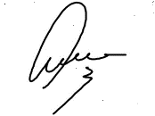Yanch V.V.

