APPROVED
Vice-rector for Academic Affairs
VSU named after P.M. Masherov
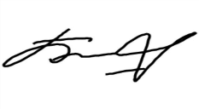Bobryk M. Yu.
«13» May 2024

SCHEDULE
Winter examination session of the 2023–2024 academic year for Master’s course students studying in English, daytime form of education of the specialty 7-06-0114-02
“Educational Management_2”
Enrolment September 2023

Examination period: 27.05.2024–14.06.2024

Discipline, teacher | Examination |  | Credit
 | Date, time | Classroom | Date, time | Classroom
Research Seminar  Rakova N.A. |  |  | 27.05.2024  16.05 | 303  33-2 Moskovsky Ave
Information and communication technologies in scientific, pedagogical and innovative activities  Sapelko T.I. |  |  | 29.05.2024  8.00 | 200e  33 Moskovsky Ave
Managing the educational process in the digital environment  Stepanov V.A. |  |  | 30.05.2024  18.10 | 212  33 Moskovsky Ave
Russian as a foreign language  Grechikho T.A./ Sorotokina E.V. | 04.06.2024  8.00 | 2  25/15 Suvorova street/  614  33 Moskovsky Ave
Theory of adult education  Dyachenko L. S. | 14.06.2024  8.00 | 425  33 Moskovsky Ave
Dean of the Faculty of Foreign Citizens Training 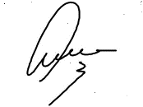Yanch V.V.

