APPROVED
Vice-rector for Academic Affairs
VSU named after P.M. Masherov
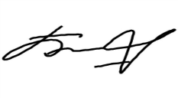Bobryk M. Yu.
«14» May 2024

SCHEDULE
Winter examination session of the 2023–2024 academic year for Master’s course students studying in English, daytime form of education of the specialty 7-06-0113-06
“Fine Arts”
Enrolment September 2023

Examination period: 28.05.2024–12.06.2024

Discipline, teacher | Examination |  | Credit
 | Date, time | Classroom | Date, time | Classroom
Methods of improvement of artistic and pedagogical skills  Senko D. S. |  |  | 28.05.2024  9.35 | 402  33-2 Moskovsky Avenue
Design and modeling of artistic and creative activities  Senko D. S. | 07.06.2024  8.00 | 402  33-2 Moskovsky Avenue
Russian as a foreign language  Mamyko N.A. | 12.06.2024  8.00 | 8  25/15 Suvorova street

Dean of the Faculty of Foreign Citizens Training 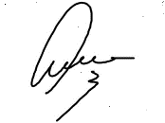Yanch V.V.

