APPROVED
Vice-rector for Academic Affairs
VSU named after P.M. Masherov
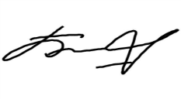Bobryk M. Yu.
«13» May 2024

SCHEDULE
Winter examination session of the 2023–2024 academic year for Master’s course students studying in English, daytime form of education of the specialty 7-06-0113-06
“Music Arts”
Enrolment September 2023/March 2024

Examination period: 27.05.2024–10.06.2024

Discipline, teacher | Examination |  | Credit
 | Date, time | Classroom | Date, time | Classroom
Performing arts  Venzhega O.Y. |  |  | 27.05.2024  9.35 | 23  Chekhov str., 11/44
World art culture  Venzhega O.Y. |  |  | 30.05.2024  9.35 | 28  Chekhov str., 11/44
Russian as a foreign language  Sorotokina E.V. | 03.06.2024  16.35 | 422  33 Moskovsky Ave
Technologies for development of students’ creative abilities  Venzhega O.Y. | 07.06.2024  8.00 | 18  Chekhov str., 11/44
Organization of extracurricular music classes  Venzhega O.Y. | 10.06.2024  8.00 | 23  Chekhov str., 11/44

Dean of the Faculty of Foreign Citizens Training 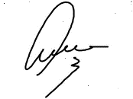Yanch V.V.

