APPROVED
Vice-rector for Academic Affairs
VSU named after P.M. Masherov
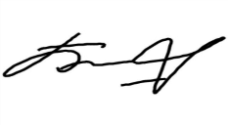Bobryk M. Yu.
«20» May 2024

SCHEDULE
Winter examination session of the 2023–2024 academic year for Master’s course students studying in English, daytime form of education of the specialty 7-06-1012-01 “Physical Education and Sports”
Enrolment September 2023/March 2024

Examination period: 03.06.2024-18.06.2024

Discipline, teacher | Examination |  | Credit
 | Date, time | Classroom | Date, time | Classroom
Private methods of adaptive physical culture for people of different ages  Poznyak Z.A. |  |  | 03.06.2024  11.30 | 31  30 Chapaev str.
Information technologies and mathematical statistics in physical culture and sports  Prokhozhiy S.A. |  |  | 04.06.2024  9.35 | 221  33 Moskovsky Ave
Research seminar  Malakh O.N. |  |  | 06.06.2024  8.00 | 31  30 Chapaev str.
Russian as a foreign language  Sosnovskaya O.A. | 12.06.2024  8.00 | 141  33 Moskovsky Ave
Special Olympics Movement for Persons with Intellectual Disabilities  Novitskaya A.I. | 18.06.2024  8.00 | 31  30 Chapaev str.
Dean of the Faculty of Foreign Citizens Training 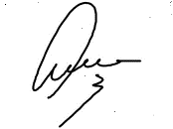Yanch V.V.

