APPROVED
Vice-rector for Academic Affairs
VSU named after P.M. Masherov
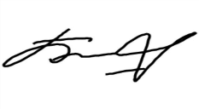Bobryk M. Yu.
«27» May 2024

SCHEDULE
Summer examination session of the 2023–2024 academic year for Master’s course students studying in English, daytime form of education of the specialty 6-05-0113-04
“Physics and Mathematics education”
Enrolment March 2024

Examination period: 10.06.2024–04.07.2024

Discipline, teacher | Examination |  | Credit
 | Date, time | Classroom | Date, time | Classroom
Research seminar  Vorobiev N.T. |  |  | 10.06.2024  11.30 | 501  33 Moskovsky Avenue
Modern problems of teaching Mathematics and computer Science  Osipov A.V. |  |  | 11.06.2024  8.00 | 537  33 Moskovsky Avenue
Russian as a foreign language  Mamyko N.A. | 17.06.2024  8.00 | 8  25/15 Suvorova street
Additional topology chapters  Podoksenov M.N. | 21.06.2024  8.00 | 142a  33 Moskovsky Avenue
Statistical methods and data analysis in educational research  Prokhozhiy S.A. | 25.06.2024  8.00 | 142a  33 Moskovsky Avenue
Methods of teaching computer Science in higher school  Osipov A V. | 29.06.2024  8.00 | 142a  33 Moskovsky Avenue
Methods of teaching computer Science in Physics and Mathematics classes  Osipov A.V. | 04.07.2024  8.00 | 142a  33 Moskovsky Avenue

Dean of the Faculty of Foreign Citizens Training 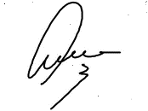 Yanch V.V.

