APPROVED
Vice-rector for Academic Affairs
VSU named after P.M. Masherov
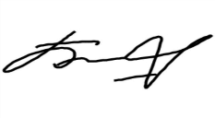Bobryk M. Yu.
«28» May 2024

SCHEDULE
Summer examination session of the 2023–2024 academic year for Master’s course students studying in English, daytime form of education of the specialty 7-06-0313-01
“Psychology”
Enrolment September 2023/March 2024

Examination period: 11.06.2024–28.06.2024

Discipline, teacher | Examination |  | Credit
 | Date, time | Classroom | Date, time | Classroom
Research seminar  Potasheva Y.L. |  |  | 11.06.2024  8.00 | 31  30 Chapaev str.
Current trends in psychological practice  Soveyko E. I. |  |  | 12.06.2024  9.35 | 31  30 Chapaev str
Psychology of personal effectiveness  Morozhanova M.M. |  |  | 17.06.2024  9.35 | 43  30 Chapaev str
Psychology of socio-perceptual activity of subjects  Semyonova N.S. |  |  | 18.06.2024  9.35 | 24  30 Chapaev str
Social psychology of science and education  Potasheva Y.L. |  |  | 19.06.2024  9.35 | 31  30 Chapaev str
Russian as a foreign language  Mamyko N.A. | 24.06.2024  8.00 | 8  25/15 Suvorova street
Modern technologies for teaching psychology in the system of higher and further education Semyonova N.S. | 28.06.2024  8.00 | 24  30 Chapaev str
Dean of the Faculty of Foreign Citizens Training 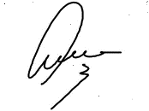Yanch V.V.

